Chapter 3 — Networking Connectors & Wiring Standards:

Coaxial Cable:
Coax is a single copper center conductor, wrapped in a plastic insolation layer, with a braided shield over that, then an outer jacket of PVC or a Teflon-type plenum-rated coating. It's big advantage: the braided shielding resists EMI/RFI (electromagnatic/radio frequency interference) and other stray signals.
Plenum vs. non-plenum: the plenum is the space between floors in multistory buildings used to circulate air, and often carries cabling too. Fire code (NFPA, National Fire Protection Association) requires plenum-rated cable there, because regular (non-plenum) insulation gives off poisonous smoke and can help fire spread like a wick. Non-plenum is cheaper, so it's fine anywhere that isn't a plenum space.
Type | Standard | Cable | Size | Connector | Status
Thinnet | 10Base2 | RG-58 | ~5mm | BNC with 50-ohm terminating resisters on both ends | Essentially obsolete for LANs
Thicknet | 10Base5 | RG-8 | ~1/2 inch | Worked the same way | Basically extinct
Cable TV cable/modem |  | RG-59  Or  RG-6 |  | F-type screw-on connector | Where coax survives today.

Twisted-Pair: UTP vs. STP, and Categories:
Twisted-pair is multiple individually insulated wires twisted together in pairs. The twists are there specifically to reduce cross-talk (interference from nearby signals) and protect against outside interference.
- UTP (Unshielded Twisted Pair): What you'll touch every day. Used in Ethernet standards like 10BaseT through 40GBaseT. It wins today because it's cheap, easy to work with, and support speeds that weren't possible a decade ago.
- STP (Shielded Twisted Pair): adds a metal foil or braid around each pair for better noise immunity in electrically noisy environments.

Categories
Each higher category is rated for a higher frequency and has more twists per inch.
Category | Frequency | Speed/use | Status
Cat 1 | 1 MHz | Voice only (POTS, Plain Old Telephone Service). Not rated for dat | Voice only
Cat 2 | 10 MHz | 4 Mbps | Obsolete
Cat 3 | 16 MHz | 10 Mbps Ethernet | Obsolete for networks
Cat 4 | 20 MHz |  | Obsolete
Cat 5 | 100 MHz | 100BaseTX (two-pair) | Largely replaced by Cat 5e
Cat 5e | 100 MHz | Gigabit. Handles crosstalk from all four pairs transmitting at once. | Practical minimum or any modern install
Cat 6 | 250 MHz | Gigabit comfortably. Standard since June 2002 | Go-to for new buildings. Common as riser cable between floors, alongside fiber
Cat 6A | 500 MHz | Better crosstalk handling lets 10GBaseT run the full 100m (regular Cat 6 has a shorter max distance at that speed) | Current
Cat 7 |  | 10 Gigabit Ethernet over 100m of copper | Current
Cat 8 |  | 25G/40G at 30m | Built for data centers

Practical Tips
- Yanking Cat 5e stretches its internal twists and can invalidate its rating. Cat 6 has a plastic spine to resist that, and Cat 7/8 add metal shielding.
- Always test and connect all four pairs, even though older setups used only two. Gigabit needs all eight wires in good shape.
- A true Cat 5e/6/7/8 install means every component end-to-end (patch cables, wall panel, patch panel) meets spec. One mismatched piece breaks the whole certification, and verifying it takes pricey test gear.

RJ Connectors:
BNC connectors don't fit UTP, so RJ (registered jack) connectors are used instead. They're attached with a crimper, just with a different die shape than BNC.
Connector | Positions / Wires | Used For | Notes
RJ-11 | Small 4/6-position jack.  Four wires (two pairs) | Phone lines and home DSL (Digital Subscriber Line) | Never used for LANs
RJ-45 | 8-position jack. Eight wires (four pairs) | Ethernet data | Unshielded wiring
RJ-48c | Looks identical to the RJ-45 | T1 circuits (long-distance WAN), not short LAN runs | Wired differently, and the wires are typically shielded. Don't mix them up by sight alone.

Straight-Through, Crossover, Rolled Cable & T568A/B:

T568A vs. 1568B:
Over 60 vendors agreed on two wiring standards, T568A and T568B, though not universally, so you'll find both in the wild. The entire difference: pair 2 (orange) and pair 3 (green) swap positions.
- T568A: green on pins 1—2,orange split accross pins 3 and 6.
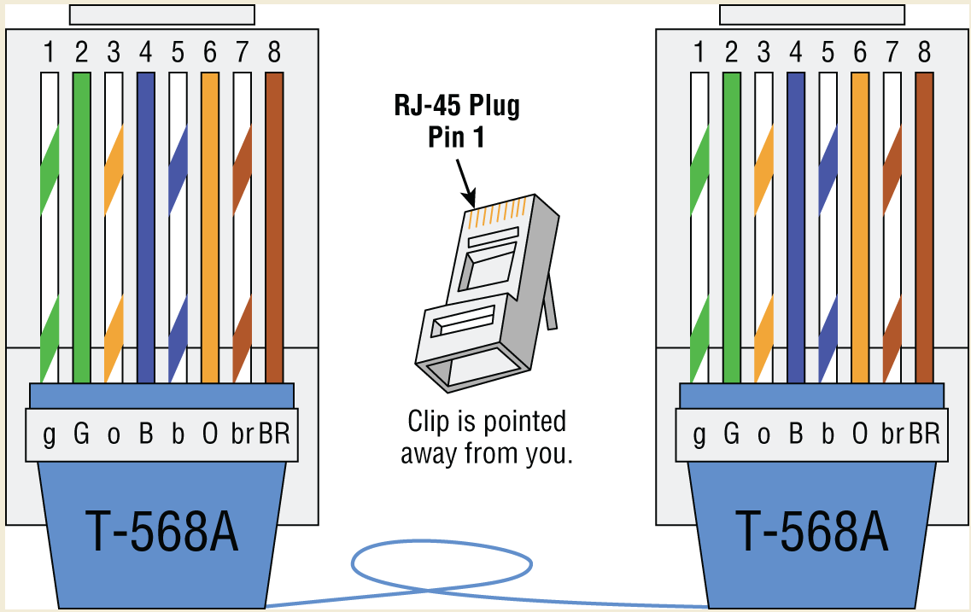
- T568B: those two pairs swapped (orange on 1—2, green one on 3 and 6).
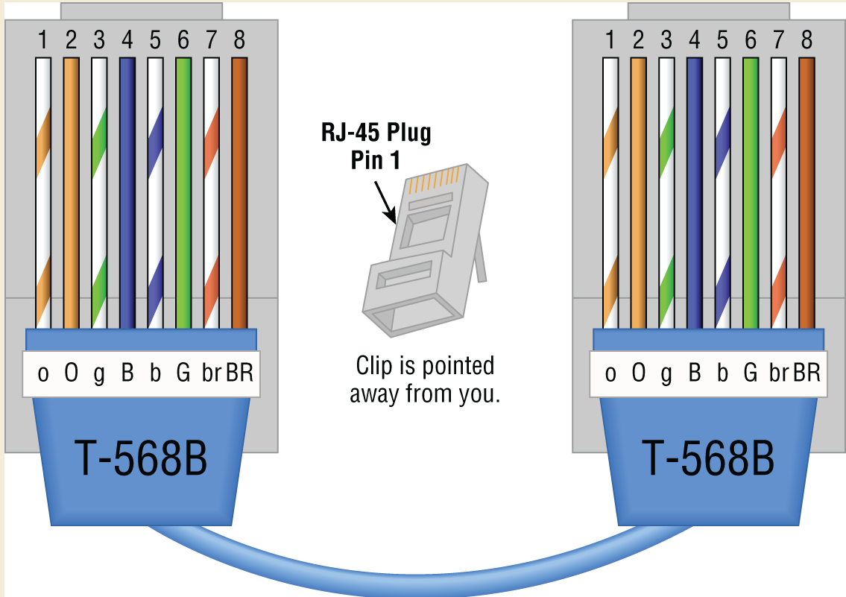
- Pins 4,5,7,8 (blue and brown pairs) never move. They're needed for 1000 Base T, PoE (Power over Ethernet), and some 100 Mbps setups.
- Since VoIP (Voice over IP) commonly shares the same wire as data today, new installs should always collect and use all eight pins.

Three Cable Types:
Cable | Connects | Wiring
Straight-through | Unlike devices: host to switch/hub, or router to switch/hub | Same standard on both ends  (T568A + T568A, or T568B + T568B).  For basic 10/100 Ethernet only pins 1, 2, 3, 6 are used, wired 1-to-1, 2-to-2, and so on.  A Gigabit straight-through is still 1-to-1 through 8-to-8  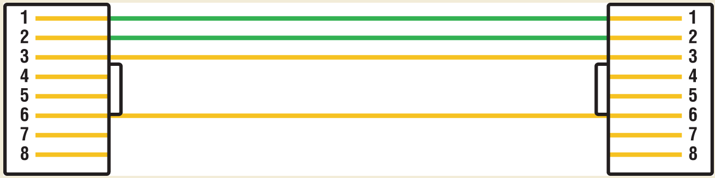
Crossover | Like devices: switch-switch,  hub-hub,  host-host,  hub-switch, or  router direct to host. | T568A on the one end, T568B on the other.  Pin 1 goes to pin 3 and pin 2 to pin 6, on one end only  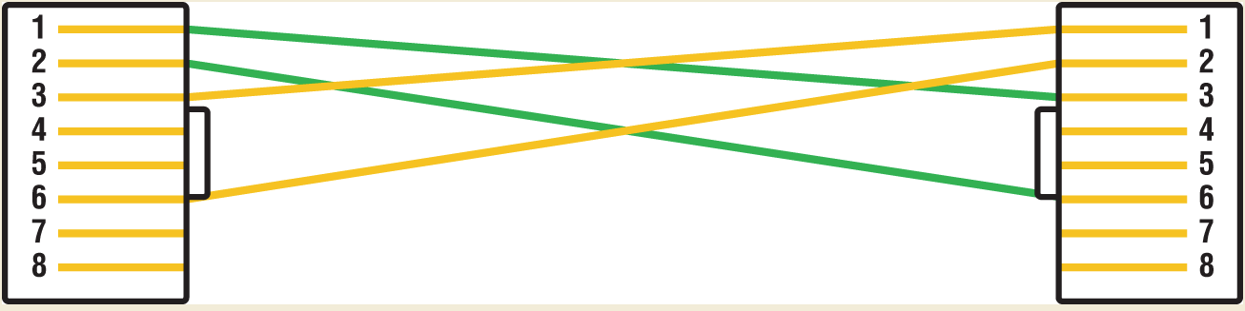
Rolled / rollover | A host's serial interface to a Cisco router or switch console port, for management access | Carries no Ethernet at all.  Easiest to make: flip the connector on one end of a straight-through cable and reattach it
For Gigabit (1000BaseT), all four pairs (all 8 pins) are used simultaneously, not just two pairs.

Crossover :
- Always label a crossover cable clearly so no one mistakes it for a regular patch cable. Plugged in wrong, the workstation can't talk to the network.
- A cable tester can confirm which type you're holding, or flag a bad cable.
- Handy trick: carry a crossover cable to test a server's NIC (Network Interface Card) directly from your laptop without going through a switch.
T1 crossover cable: niche, used only to connect to CSU/DSU (Channel Service Unit/Data Service Unit) devices back-to-back. It swaps pins 1/2 with pins 4/5 rather than using the Ethernet crossover point.
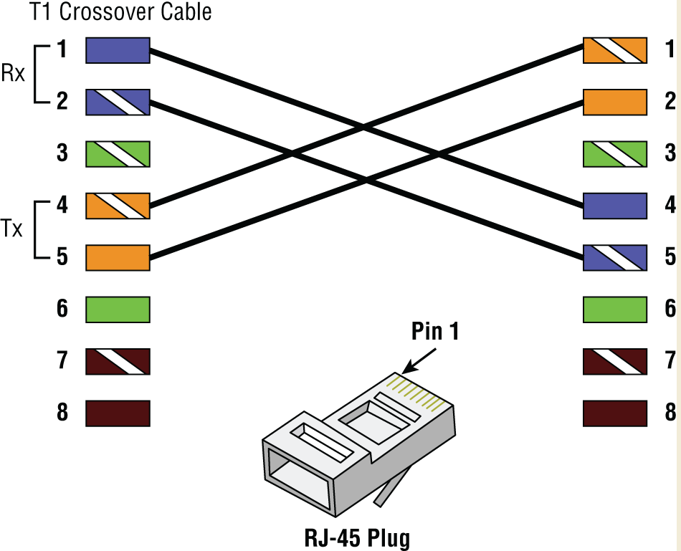

Fiber-Optic Cable & Connectors:
Fiber transmits digital signals as light rather than electricity, which makes it immunebu EMI/RFI.
Construction, inside out: a glass or plastic core (glass carries father, plastic is cheaper), then cladding that reflects light back into the core, then a flexible buffer, sometime Kevlar armour, then a PVC or plenum jacket.
- Pros: totally immune to EMI/RFI, and can run up to ~40 km C
- Cons: harder to install, more expensive (cable and test equipment), and harder to troubleshoot.

Single-Mode vs. Multimode:
 | SMF (Single-Mode Fiber) | MMF (Multimode Fiber)
Light | One laser-driven ray (one or two glass strands, with LED or laser sources) | Multiple LED-driven rays, dispersed across multiple paths and reflected back by the cladding
Distance | Long runs.  Up to 90x farther than multimode, 40-80km depending on the transceiver | Medium runs, up to ~3000ft.  Gets unreliable beyond that
Speed | Faster | Great with bandwidth over medium distances
Cost / install | Trickier.  Shouldn't be crimped or bent sharply | Cheaper.  Comes in glass or an easier-to-install plastic version.
Typical use | Between buildings | Within one building

Connectors
Connector | What it is | Notes
ST (straight tip) | AT&T designed, bayonet twist-lock (like BNC) | Popular for SMFWAN links.  won't loosen over time.
FC | Similar to ST, but with a screw mechanism | less common
SC | Square, push-on/off.  Nicknamed “Square Charlie” | Popular in MMF installs, but larger and being phased out for smaller connectors
MT-RJ | SSF (small form factor).  One-third the size of SC/ST, combines TX/RX in one connector | keyed for single polarity.  No polishing or epoxy needed
LC | SFF.  Resembles an RJ connector with a spring-loaded detent. | Smaller for higher port density.  Popular for Fibre Channel and Gigabit Ethernet.  Can't be disassembled to swap TX/RX like SC can
MPO | High-density SFF connector, fitting 2,8,12, or 24 fibers in one plug | Typicallyfans out to multiple LC connectors for 10-100 Gbps per connection
SFF connectors pack more terminations into less space.

APC vs. UPC:
These aren't connectors but polish/finish types. They affect return loss (decibel loss) from reflectance, not the core light path.
- UPC (Ultra Physical Contact): straight cut. Reflects some light into the cladding instead of the core, causing loss. Colour-coded blue.
- APC (Angled Physical Contact): angled cut that significantly reduces that loss. Colour-coded green.

Related Bits:
- FDP (fiber distribution panel): handles fiber termination and distribution, with a cable tray and splice drawer.
- Fibre Channel (FC): a seperate high-speed (2-32 Gbps) storage transfer protocol used for SANs (Storage Area Networks). It delivers raw data losslessly, doesn't follow the OSI model, and uses different transceivers than Ethernet optical modules.

Copper vs. Fiber:
- Distance: fiber wins for multi-mile runs. Copper tops up around 1500 ft before needing signal regeneration, and the UTP standard maxes at .
- Security: fiber wins for high-security needs, since it doesn't create a readable magnetic field.

Twinaxial Cable & DAC
(Textbook only, not mentioned in study guide.)
- Twinaxial (twinax) cable is used for short-distance, high-speed connections like 10G/40G Ethernet in data centers. It's copper-based, so it's significally cheaper than fiber for runs of 10 meters or less.
- DAC (Direct Attach Copper) is part of the twinax family: fixed-length (~26-28 AWG, American Wire Gauge) cables with connectors on both ends for direct device-to-device communication. It uses electromagnetic shielding (like STP) to boost speed and reliability.

Transceivers & Media Converters:
(Textbook only, not mentioned in Study Guide)
A transceiver combines a transmitter and receiver in one housing. They're used in everything from cell phones to fiber-optic systems.
Module | What it is | Speed
SFP (Small Form-factor Pluggable) | Compact optical transceiver module
SFP+ | Enhanced SFP | Up to 16 Gbit/s
QSFP (Quad SFP) | Hot-pluggable transceiver connecting network hardware to fiber or copper | 4 x 1 Gbps
QSFP+ | Enhanced QSFP | 4 x 10 Gbps
QSFP28 | Used for 100 Gbps links | 4 x 28 Gbps
Fiber transceivers come in two flavours:
- : data flows one way only.
- Bidirectional: data flows both way simultaneously over a single strand by seperating the two devices' transmission wavelengths (per IEEE 802.3ah).
Media converters handle switching between media types:
- Single-mode fiber to Ethernet
- Multimode fiber to the Ethernet
- Fiber to coaxial
- Single-mode to multimode fiber

Serial Cables (RS-232, DB-25, USB):
(Textbook only, not mentioned in Study Guide)
Serial communication sends one bit after another. Parallel sends bits in groups like the old Centronics printer cable, now replaced by USB.
- RS-232 (Recommended standard 232): a common serial standard connecting DTE and DCE (Data Terminal Equipment and Data Communication Equipment, like a computer to an external modem), typically via a DB-9 connector. Mostly obsolete now, replaced by USB/USB-C.
- DB-25: from the D-series connectors invented in 1952. It has 25 pins in a “B” size shell and was RS-232's usual connector. Rarely seen today. Even DB-9, once commonly used for Cisco console cables, has mostly been replaced with USB.
- USB (Universal Serial Bus): now the standard serial bus on motherboards. Typically 4 external ports, expandable via hubs, technically supporting up to 127 devices (rarely practical). Used for printers, scanners, keyboards, mice, and more.

Cable Properties (Speed, Distance, Duplex, Noise Immunity, Frequency):
Every cable choice trades off these five things:
Property | What to know
Speed | Varies by network area. Core areas often run 10Gbps +. Distribution/access area (where users connect) typically run 100/1000 Mbps, through demand keeps pushing that up
Distance | All cables suffers attenuation (signal degradation over distance). Twisted-pair maxes out at 328 ft (100 m) per segment
Duplex | Half-duplex: can't send and receive at once, like a walkie-talkies.  Full-duplex: send and receive simultaneously, doubling effective throughput.  Full-duplex is standard in modern switched networks.
Noise immunity | Two magnetic-flux issues (below)
Frequency | Sets a cable's max bandwidth. Cat 5e tops out at 100 MHz (fine for 1Gbps over short runs). Cat 6 handles 250 MHz and 1 Gbps comfortably, so it's the better choice for longer runs like between floors.

Noise immunity, the two issues:
- Tapping: Copper's current can be “tapped” and read without even cutting the cable. STP makes this harder but not impossible. Fiber carries light, not electricity, so it's far more tap-resistant: tapping it means physically cutting and repairing the cable, which tends to get noticed.
- External EMI: Motors, speakers, and ballasts can introduce unwanted current in nearby cupper, so keep cabling away from them.

Wiring Distribution: MDF/IDF, Blocks, Demarc:
On the building side signals pass through an MDF/IDF, terminate on a 66 or 110 block, and hand off to the provider at the demarc, the exact line between “your problem” and “their problem” when troubleshooting.

Distribution Frames:
- MDF (Main Distribution Frame): the building's central wiring reference point and WAN termination point, where internal lines connect to external (telco) lines.
- IDF (Intermediate Distribution Frame): connects to the MDF from an equipment/telecom room, giving more flexible distribution throughout the building.
- 25-pair cable (aka feeder cable): bundles 25 wire pairs under one jacket. Mainly for telephone backbone/cross-connecting cabling, cutting down on clutter.

Punch-Down Blocks
Block | What it is | Notes
66 block | Old analog telephone termination standard (from 1962).  Uses 25-pair cable across 50 rows. | Mostly in older buildings
110 block | The modern replacement  Used for both phone (RJ-11) and network (RJ-45) connections. | Sizes from 25 to 500+ pairs.  Supports 1 Gbps with Cat 6+ (though Cat 6's size makes a tight fit)
Krone | European equivalent | 110-block-compatible
BIX block | Another punch-down type, terminating up to 25 pairs | lip-in fitting, no pre-stripping of wires

The Demarc:
- Demarc (demarcation point): the exact point where the service provider's responsibility ends. Often at the MDF, usually just an RJ-45 jack where your CSU/DSU connects to the WAN.
- Admins test both sides of the demarc to figure out if a problem is internal or the provider's fault.
- Demarc extension: the cabling between the demore and your actual office space.
- Smart jack (aka NID/NIU, Network Interface Device/Unit): a provider-owned interface, often installed because you can't directly test the bare demarc jack. It can be powered and looped for testing, and may also handle code/protocol conversion so the provider's signal works with your internal gear.

Core Insights:
Concept | The thing to remember
Coax | Braided shield resists EMI/RFI.  Thinnet/thicknet (BNC) are obsolete.  Survives as RG-6 /RG-59 with F-type for cable modems.
Plenum | Air space between floors.  Fire code requires plenum-rated cable there.  (non-plenum gives off poisonous smoke)
UTP vs. STP | Twists cut crosstalk.  STP adds foil/braid for noisy environments.
Categories | Cat 5e = practical minimum (100 MHz, Gigabit).  Cat 6 = 250 MHz.  Cat 6A = 500 MHz, 10GBaseT at 100m.  Cat 8 = 25G/40G at 30m.
Certification | Every component end-to-end must meet the category specs.
RJ connectors | RJ-11 = phone/DSL.  RJ-45 = Ethernet.  RJ-48c looks like an RJ-45, but it is for T1.
T568A vs. T568B | Only the orange and green pair swap.  Same on both ends = straight-through.  A + B = crossover.
Cable types | Straight-through = unlike devices.  Crossover = like devices.  Rollover = Cisco console, no Ethernet.
SMF vs. MMF | SMF = laser, long distance, between buildings.  MMF = LED, cheaper, within a building.
Fiber connectors | ST(twist),  SC (square, push-pull),  LC (small, RJ-like),  MT-RJ (TX/RX in one),  MPO (up to 24 fibers).
APC vs. UPC | Polish types.  APC = angled, green, less loss.  UPC = straight blue.
Twinax / DAC | Cheap copper for ≤ 10m high-speed data center links.
Transceivers | SFP -> SFP + (16 Gbit/s).  QSFP (4x1) -> QSFP+ (4x10) -> QSFP28 (4x28, 100G).  Bidirectional = one strand, two wavelengths.
Serial | RS-232 with DB-9/DB-25, now replaced by USB  (up to 127 devices)
Cable proporties | Speed,  distance (UTP = 328 ft/100m),  duplex,  noise immunity (fiber resists tapping),  frequency.
Wiring distribution | MDF (main, WAN termination) -> IDF.  66 block = old phone.  110 block = modern.  Demarc = where the provider's responsibility ends.  Smart jack = loophole test point.

Abbreviations:
Abbreviation | Stands for
APC | Angled Physical Contact
AWG | American Wire Gauge
BIX | Building Industry Cross-connect
BNC | Bayonet Neill–Concelman
Cat | Category
CSU/DSU | Channel Service Unit/Data Service Unit
DAC | Direct Attach Copper
DB | D-subminiature (D-series) connector
DCE | Data Communication Equipment
DSL | Digital Subscriber Line
DTE | Data Terminal Equipment
EMI | Electromagnetic Interference
FC | Fibre Channel (also the FC fiber connector)
FDP | Fiber Distribution Panel
IDF | Intermediate Distribution Frame
IEEE | Institute of Electrical and Electronics Engineers
LC | Lucent Connector (local connector)
MDF | Main Distribution Frame
MMF | Multimode Fiber
MPO | Multi-fiber Push-On

